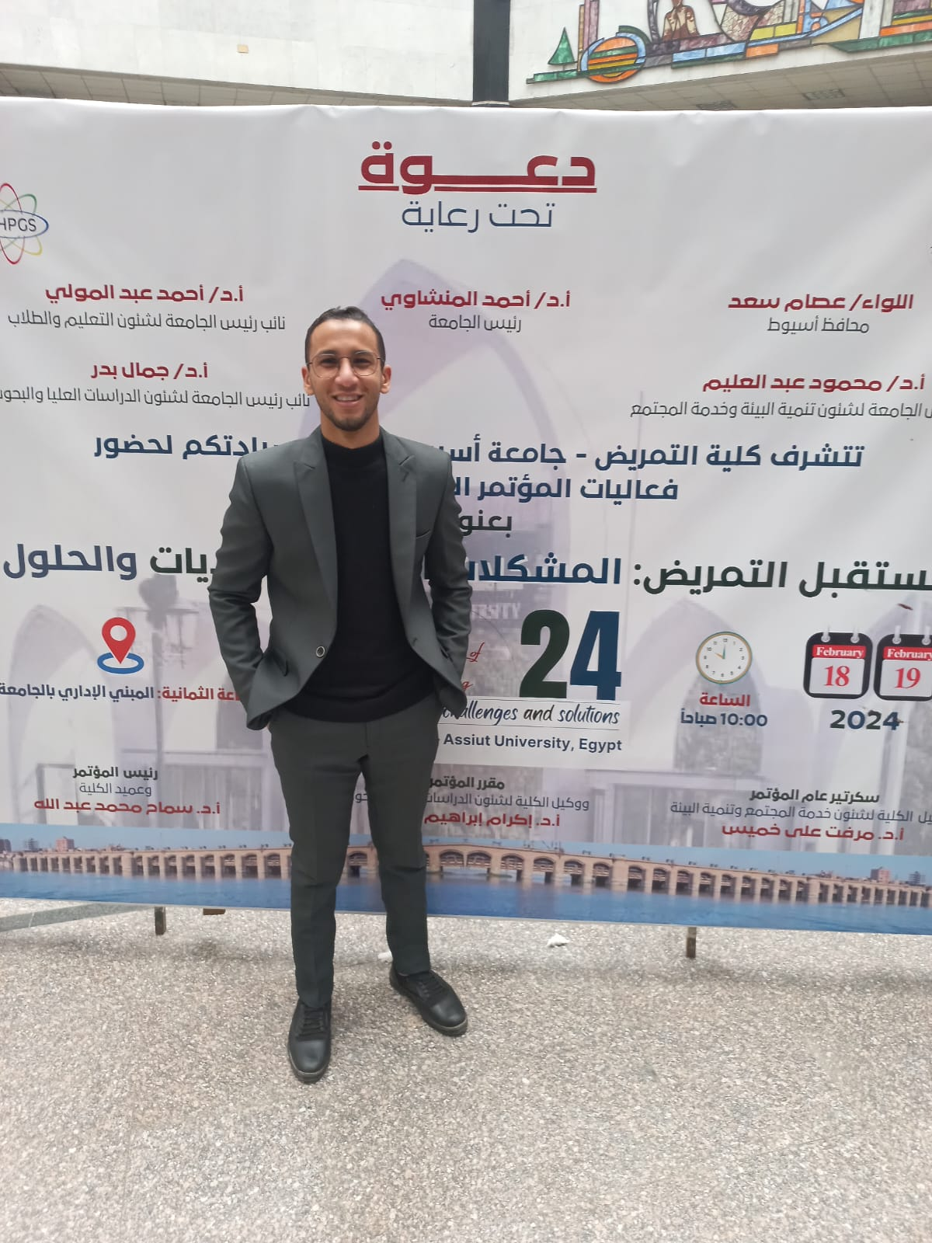**Curriculum Vitae**

**Sayed Anwar Sayed Hasab El Naby**

**Contact Information**:

* Address: New valley , Egypt
* Email: **sayedhasabelnaby@aun.edu.eg**
* Phone:**01098785298**

**Professional Summary:**

A dedicated nursing professional with a strong academic and teaching background, currently pursuing a Master's degree in critical care and emergency nursing .

**Education**

* Faculty of Nursing- Assuit University
* Department: critical care and emergency nursing department
* Faculty of Nursing-Assuit University
* Year of Graduation: 2020

**Professional Experience:**

* Demonstrator Faculty of Nursing - Assiut University
* -Department: critical care and emergency nursing department
* Duration: 29\6\2022– Present

**Responsibilities**:

* Assisting in undergraduate courses and practical sessions.
* Supporting research activities in nursing administration.
* Mentoring and guiding students in academic and clinical settings.

**Skills**:

* Teaching and mentoring in nursing practices.
* Effective communication and leadership skills.
* computer skills – Microsoft office (word –excel – power point )

**Certifications**:

* -Research design workshop
* -BLS workshop
* -First aid workshop
* -Infection control workshop

**Languages**:

* Arabic: Native
* English: Proficient